**Exercise：Packet Tracer – Build a network, setup IP address, Test connectivity**

**File: 13 The Cisco Troubleshooting Methodology_20241209.pkt**

**Student Name:** Name (Select ):

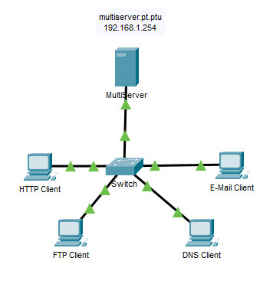

**Objectives**

Add a PC and a Server in the network. Configure IP address for the new devices, then test connectivity with network testing commands.

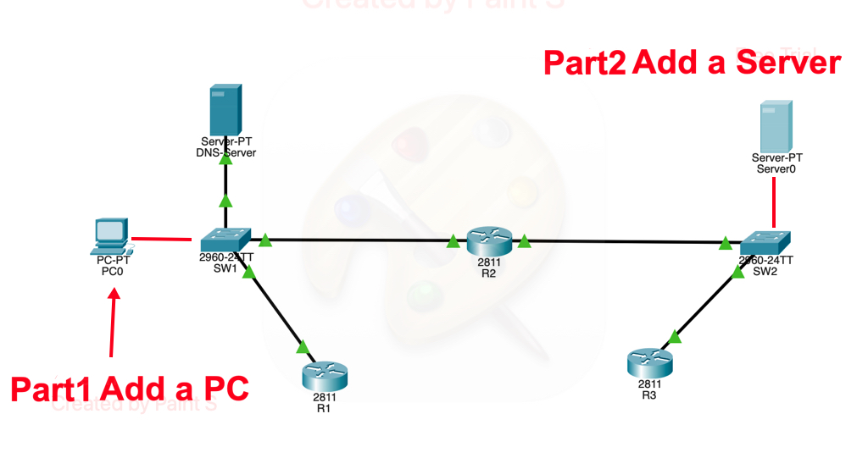

**Instructions**

**Part 1: Add a PC0 and connect it to SW1**

1. Add a PC.
2. Connect **PC0** FastEthernet0 to **SW1** FastEthernet0/4 with a Copper Straight-Through cable.

**Part 2: Add a Server and connect it to SW2**

1. Add a Server.
2. Connect **Server0** FastEthernet0 to **SW2** FastEthernet0/3 with a Copper Straight-Through cable.

**Part 3: Start DHCP and DNS services on DNS-Server**

1. Select **Services** tab of **DNS-Server**
2. Select DHCP service in the left menu.
3. Turn on the DHCP service.
4. Configure the following IP addresses
   * Dafault Gateway: **10.10.10.2**
   * DNS Server: **10.10.10.10**
   * Click **Save** button.
5. Select DNS service in the left menu.
6. Turn on the DNS service.
7. Select No. 1 r2 line in the list.
8. Click **Save** button.
9. Close the window of DNS-Server.

**Part 4: Configure IP address of PC0**

1. Select **PC0 – Desktop – IP Configration.**
2. Select **DHCP** option. Wait until IP address is assigned such as 10.10.10.3.
3. Record its IP Address, Subnetmask, Default Gateway, and DNS server.

IP Address:       
Subnetmask:       
Default Gateway:       
DNS server:

1. Close **IP Configration.**

**Part 5: Configure IP address of Server0**

1. Select **Server0 – Desktop – IP Configration.**
2. Select **Statistic** option.
3. Configure the following IP addresses.
   * Ipv4 address: **10.10.20.3**
   * Subnet Mask: **255.255.255.0**
   * Default Gateway: **10.10.20.2**
   * DNS server: **10.10.10.10**
4. Close IP Configuration.
5. Open Command Prompt.
6. Run “**ipconfig /all”** command in the command prompt.
7. Record the output.

C:\>ipconfig /all  
IPv4 Address:

Subnet Mask:

Default Gateway:

DNS Server:     

**Part 6: Test connectivity from Server0 to PC0**

1. Note the PC0’s IP address, which is checked in Part4.
2. Open Command Prompt of Server0.
3. **Server0** – **Desktop** – **Command Prompt**.
4. Run **ping <PC0’s IP address>** command in the command prompt.
5. Confirm ping return response from PC0.
6. If it becomes “Timeout”, do troubleshoot and fix it.

**Part 7: Test connectivity from PC0 to Server0**

1. Note the Server0’s IP address, which is checked in Part5.
2. Open Command Prompt of PC0.
3. **PC0** – **Desktop** – **Command Prompt**.
4. Run **ping <Server0’s IP address>** command in the command prompt.
5. Confirm ping return response from Server0.
6. If it becomes “Timeout”, do troubleshoot and fix it.

Close the Packet Tracer.